AN OVERVIEW OF EYECELL, AN EYE REGENERATION STIMULATOR

BAILEY E. AUSTIN, M.Sc.

The human eyes are incredible organs. Like a camera lens focuses light on film, the human eyes focus light through the cornea and retina, allowing one to see and focus. However, when the eyes are damaged and vision is impaired, the outcome can be detrimental to the quality of life. Worldwide, over 200 million people are affected by blindness or vision loss. The following retinal degenerative diseases are responsible for blindness and impaired vision:
- Age-related macular degeneration (AMD) affects nearly 170 million people
- Wet macular degeneration affects over 20 million people and is caused by leaky blood vessels inside the human eye
- Dry macular degeneration affects over 20 million people and is caused by local inflammation, oxidative stress, and lipofuscin accrual in the retinal pigment epithelium
- Diabetic retinopathy affects over 20 million people and is the culprit of retinal blood vessel damage—the light-sensitive tissue that lines the posterior aspect of the eye, allowing for fine detail visualization
- Retinitis pigmentosa
- Stargardt’s disease
Retinal degenerative disease costs worldwide are escalating to $343 billion and ever increasing as the worldwide population continues to age. The EyeCell regeneration stimulator may be a solution to alleviate symptoms of these retinal degenerative disease, improve and potentially restore lost vision, and lower the global costs associated.

ABOUT EYECELL™
The EyeCell™ eye regeneration stimulator and micro pump system was developed to deliver a safe and efficient product that can potentially permit eye regeneration and restored vision. EyeCell™ has designed two products for eye regeneration: an implantable micro-regeneration stimulator and micro-pump, and a non-invasive eye patch and external stimulator and pump. The non-invasive eye patch is lined up with the eye through the patch which is worn 20-40 minutes per day, every other day. The stimulator in each device controls the release of SDF-1, IGF-1, and more than 8 other regeneration promoting cytokines, proteins that are important in stem cell signaling. Each device’s micro-pump is refilled daily or weekly with a patented EC-15 fifteen part eye regeneration blend that contains stem cells, growth factors, micro RNAs, exosomes, nutrient hydrogel, anti-inflammatory agents and eye matrix. Healing eye injuries, reducing eye inflammation, reduction of pain and infection risk are the ultimate goals of each device.
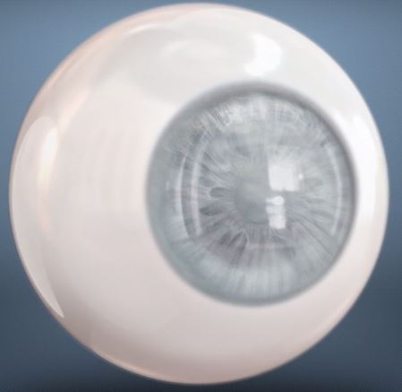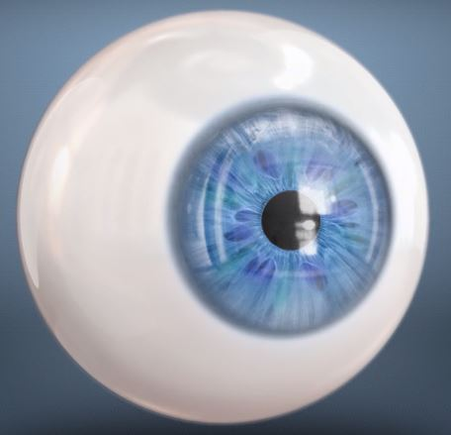
Eye with cornea degeneration Vision restored due to new cornea

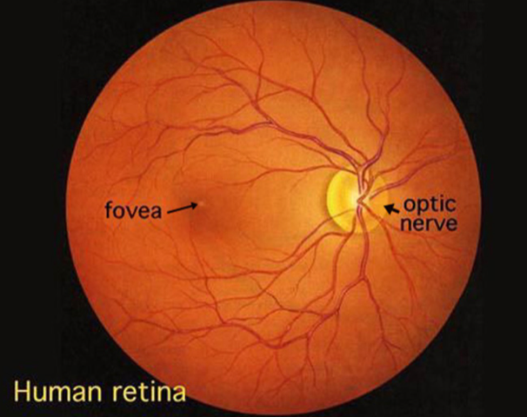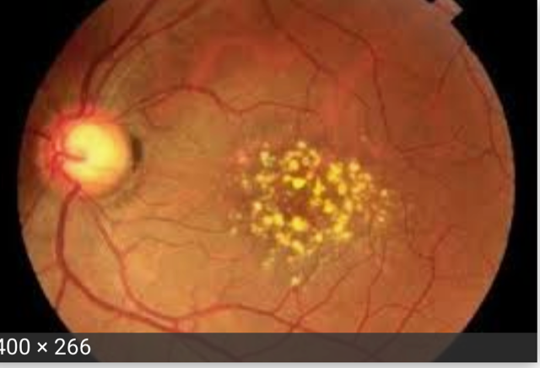
Healthy eye retina Human retina affected by macular degeneration

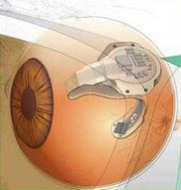
Implantable EyeCell model EyeCell eyepatch model
EYECELL™ TECHNOLOGY
EyeCell™’s ultimate goal is safety and efficiency in regards to delivering a product that has the capability of permitting complete eye regeneration. EyeCell™ consists of these three components:
- a micro stimulator that stimulates protein expressions through bioelectric controlled regeneration
- a re-fillable, programmable repeat delivery capable infusion pump
- a specially formulated stem cell, growth factor and matrix based mixed composition for ocular tissue regeneration
This patented micro stimulator sends bioelectrical signals to eye tissues cells, causing the discharge of distinct proteins. Meticulous protein release can be stimulated through the application of various signals exclusive to the stem cell attraction and retinal regeneration.
The EyeCell™ has the potential to stimulate IGF-1 (insulin growth factor), a gene that aids in the salvaging of retinal cells after bioelectric signaling release.

IGF-1
Acknowledged as a crucial component for wound healing and tissue repair, IGF-1 is activated in response to injury in most tissues and the brain¹. Furthermore, a study published by The Japanese Journal of Ophthalmology demonstrated that electrical stimulation enhances IGF-1 replication in cultured Müller cells².

EyeCell™’s primary function is to directly transport stem cell growth factors to the wound site and overly express SDF-1, a stem cell homing signal protein and potent arteriogenic factor.
SDF-1 is known to be one of the most potent stem cell homing signals as well as to improve blood flow and tissue reconstruction in numerous studies in various models and tissues over the past decade without serious side effects reported.

SDF-1
The concept of the homing in the stem cell recruitment process is the most crucial step of stem cell transplantation³. It is the navigation process that enables stem cells from red bone marrow through the blood, the vessels, and to organs throughout the body, and in this case, breast tissue.
The Expert Opinion on Biological Therapy journal published an article on SDF-1’s capabilities in regenerative medicine. The study shows that SDF-1 plays a huge role in tissue engineering. They found that when tissue is injured, the organ in the injured area overly expresses SDF-1, therefore an elevated SDF-1 level results⁴. CD34+ progenitor cells, the cells found in red bone marrow that help create blood, are recruited and retained by SDF-1 to that injured site⁴.
EyeCell™’s secondary function is the continuation of recruiting and delivering vast quantities of stem cells to the wound site. Its tertiary function is to cause blood flow surge at the wound site from producing and attracting endothelial progenitor cells and increased expression of VEGF.

VEGF

Vascular endothelial growth factor (VEGF) regulates the development of new blood vessels from existing blood vessels by inducing growth, movement, and permeability of blood vessel cells, hence the capability of the EyeCell™’s bioelectric stimulation mechanism to potentially cause increased blood flow to the breast tissue when therapy is administered⁵. Cell Transplantation journal presented a study that indicates in situ electrostimulation, through a cell and cytokine free stimulation system, enhanced heart muscle function and increased blood vessel development through the production of VEGF⁶. In situ electrostimulation is the face of the future in the repair of the heart and other organs; it also has the capability of preparing tissue for cell-based therapy treatment⁶.
EyeCell™’s final function is to lower the pain level at the wound site.

ELECTRICAL STIMULATION CLINICAL DATA
A multicenter, prospective, randomized, double-blind, sham-controlled study conducted by Gall et al applied repetitive transorbital alternating current stimulation to partially blind patients in an effort to activate residual vision⁷. The volunteer sample of patients recruited presented with optic nerve damage and a mean age of 59.1 years. For 10 week days, rtACS (n = 45) or sham-stimulation (n = 37) was applied to patients daily for 50 minutes. The efficacy measure of primary outcome was super-threshold visual fields two days after the final day and at the two-month follow-up evaluation. Changes to brain physiology were evaluated through visual fields, reaction time, visual acuity, and resting-state EEGs, with secondary outcome measures near-threshold⁷. Compared to the sham-stimulation’s 2.5% overall improvement, The rtACS-treated group had a substantially greater mean improvement in visual field of 24%. Both within- and between-group comparisons, visual improvement continued for at least two months. Further analysis showed that near-threshold visual fields in the central 5° and reaction times improved, along elevated static perimetry after rtACS. Compared to shams, visual acuity never changed⁷.

Edward C. Kondrot, MD, our Executive Vice President of Clinical Studies and Co-Founder, summarized the following three studies on the use of micro-current for age-related macular degeneration.

In a two year study (1983-1985) Grace Halloran, PhD, directed a study that consisted of 114 patients. Out of the 114 patients, 18 of those patients had macular degeneration and 16 of those patients’ vision improved with micro-current therapy. Seventy-eight out of the 114 patients had retinitis pigmentosa and 62 of those patients showed improvement. Eighteen patients out of the 114 patients had other various retinopathies and 16 of those patients improved. Fourteen of the patients who did not show any signs of vision impression remained the same and ultimately would have been expected to lose their vision. Two of the patients continued to slightly lose their vision.

Dr. Jarding and Dr. Michael directed a 10-year clinical study on macular degeneration treated with micro-current. The study involved 400 eyes and 78% of the eyes showed from 1-9 lines of improvement in reading of a visual acuity chart, and over 50 percent improved from 2-9 lines of improvement. Two of the patients in the study presented with retinal vein occlusion and macular swelling. Each patient presented with drastic progress in vision as a result of micro-current therapy.

Damon Miller, MD, conducted a study on the effects of micro-current stimulation on eye diseases such as Stargardt’s disease, retinitis pigmentosa and other degenerative retinal diseases. In his study, out of the
120 patients, 83% of the patients showed improvement of greater than or equal to two lines of visual acuity in one or both eyes.

INITIAL PRE-CLINICAL RESEARCH
The Moran Eye Center and Utah Lion’s Eye Bank supplied two fresh, healthy human cadaver eyes for this study. The eyes were enucleated and frozen at -80°C to preserve tissue structure⁸. From there, the optic nerve, anterior aspect, lens, and vitreous humor were all removed from the eye and they were each dissected into three pieces, with a total of six pieces. The six pieces of eye to be tested consisted of the sclera, choroid and retina layers⁸.
For 20 minutes, five of the samples were stimulated with various electrical signals that were to instigate the discharge of one particular target protein⁸.
Sample 1 | Sample 2 | Sample 3 | Sample 4 | Sample 5 | Sample 6
VEGF | SDF-1  (CXCL12) | IGF1 | CRYAA | ELN | Control
Table 1: Description of type of gene specific bioelectric stimulation⁸
Tissue samples were positioned between two electrodes connected to a GRASS S88 Square Pulse Stimulator as shown in Figure 1 to induce stimulation. The control sample was the sixth sample and was frozen immediately⁸.

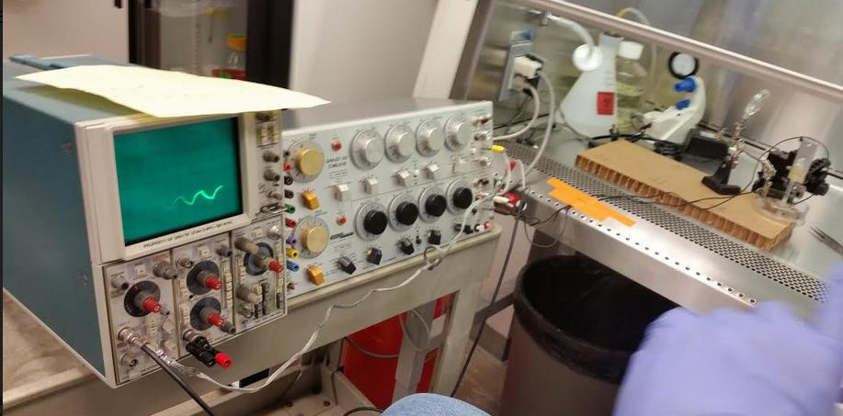
Figure 1: Setup of the equipment and sample used for bioelectric stimulation.
The six samples were immediately taken to the University of Utah DNA Extraction CORE facility in an effort to isolate the mRNA from the samples after stimulation (PureLink RNA Mini Kit, Thermofisher) and evaluated for quality and reverse transcribed to generate cDNA (RT² First Strand Kit, Qiagen)⁸. Real time PCR was performed for each trial using RT² SYBR Green ROX qPCR Mastermix (Qiagen) combined with the 96-well RT² Human Macular Degeneration Profiler PCR Array plate (Qiagen)⁸. Eighty-four various genes linked to retinal regeneration, as well as quality control and housekeeping genes, were tested from these plates⁸. Software provided by Qiagen through the GeneGlobe Data Analysis Center was used to assess the real-time PCR trial results from the real-time PCR trials compared to the control group to determine to what degree target genes, and others, were upregulated by bioelectric stimulation⁸.
Signal: | VEGFA | SDF1 (CXCL12) | CRYAA,CRYAB | IGF1 | ELN
Fold-Change of expressed cDNA (compared to control): | 1.10 | 64.91 | 28.92, 5.59 | N/A | N/A
Table 2: Summary of the real time PCR results for genes of interest⁸.
Three of the genes were upregulated, especially SDF1 and CRYAA, which had significant upregulation and contained 64.91 and 28.92 times the amount of cDNA found in the control sample⁸. Unfortunately, the results for IGF1 and ELN were not conclusively determined, as there wasn’t sufficient cDNA harvested from either the sample or control tissue to provide meaningful data. The strongest signal came from the signal used to stimulate SDF1 (CXCL12), as 60 other genes were also upregulated with the highest, IL6, upregulated over 2,000 fold⁸.

In summary, the EyeCell™ has the POTENTIAL to provide the following characteristics and benefits listed, making it a revolutionary product that could change the lives of those affected by visual impairment:
- Stem cell regeneration micro-current device for regeneration, healing and improvement of blood flow
- Anti-angiogenic (stops over blood supply) signaling micro-current device
- Stem cell growth factor cocktail compositions to be injected
- Micro-pump for sustained delivery of eye repair agents over time
- Eye health vitamins for post procedure healing
- Microcurrent acupuncture point positioned eye patch
- The EyeCell™ micro-current devices are designed to provide healing of injuries, reduce inflammation, reduce pain and risk of infection
- EyeCell™ collaborative researchers have treated nearly 3000 patients to date with 90% of them demonstrating improvement directly related to the micro-current therapy
- Seal off leaky blood vessels
- Reduce inflammation
- Regenerate tissues healing
- Stop over blood supply
- Increase oxygenated blood supply when needed
- Reduce infection risk
- Reduce Pain

REFERENCES

- Johnston, B. M., Mallard, E. C., Williams, C. E., & Gluckman, P. D. (1996). Insulin-like growth factor-1 is a potent neuronal rescue agent after hypoxic-ischemic injury in fetal lambs. The Journal of clinical investigation, 97(2), 300-8.

- Sato, T., Fujikado, T., Morimoto, T. et al. Jpn J Ophthalmol (2008) 52: 217. https://doi.org/10.1007/s10384-008-0533-y

- Lapidot, T., Dar, A., & Kollet, O. (2005). How do stem cells find their way home? Blood, 106(6), 1901-1910. Accessed November 14, 2018. https://doi.org/10.1182/blood-2005-04-1417.

- Ting Ting Lau & Dong-An Wang (2011) Stromal cell-derived factor-1 (SDF-1): homing factor for engineered regenerative medicine, Expert Opinion on Biological Therapy, 11:2, 189-197, DOI: 10.1517/14712598.2011.546338

- E. Yaniz-Galende, R.J. Hajjar,16 - Stem cell and gene therapy for cardiac regeneration, Editor(s): Ren-Ke Li, Richard D. Weisel, Cardiac Regeneration and Repair, Woodhead Publishing, 2014, Pages 347-379, ISBN 9780857096586, https://doi.org/10.1533/9780857096708.4.347.

- Spadaccio, C., Rainer, A., Marco, F. D., Lusini, M., Gallo, P., Sedati, P., … Genovese, J. A. (2013). In Situ Electrostimulation Drives a Regenerative Shift in the Zone of Infarcted Myocardium. Cell Transplantation, 22(3), 493–503. https://doi.org/10.3727/096368912X652977

- Gall C, Schmidt S, Schittkowski MP, Antal A, Ambrus GG, Paulus W, et al. (2016) Alternating Current Stimulation for Vision Restoration after Optic Nerve Damage: A Randomized Clinical Trial. PLoS ONE 11(6): e0156134. doi:10.1371/journal. pone.0156134

- Eyecell TAP Milestone I Report. Unpublished raw data.

